Project Development Phase Model Performance Test

Date | 12 March 2026
Team ID | 6997f7cc05fb21b07dca82fd
Project Name | Visualizing Housing Market Trends: An Analysis  of Sale Prices and Features using Tableau
Maximum Marks

Model Performance Testing:

S.No | Parameter | Screenshot / Values
1. | Data Rendered | Housing data with 21 columns and 2000+ records loaded from CSV into Tableau.  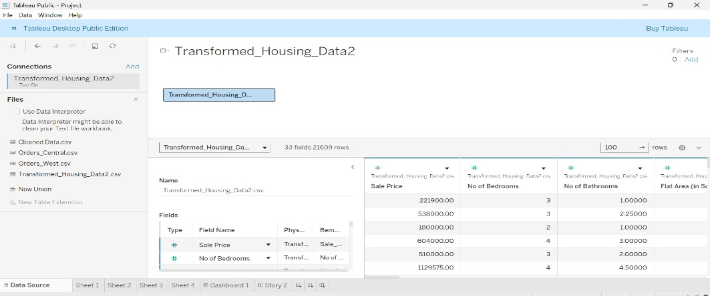
2. | Data Preprocessing | - Removed null values from 'price' and 'renovation date'  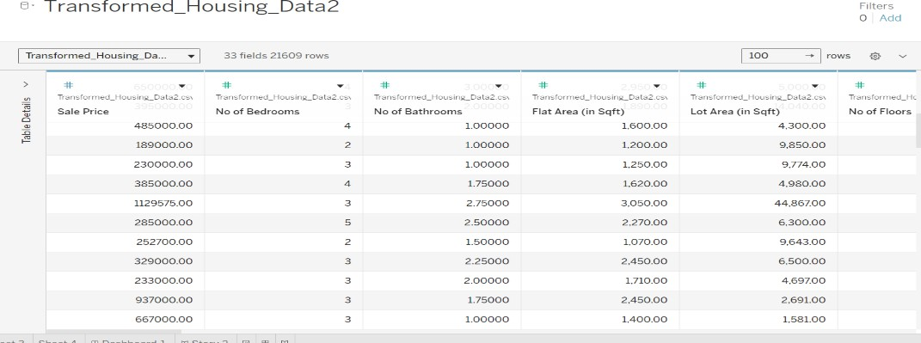
3. | Utilization of Filters | Filters applied on: Sales Price  Age of House (in years)

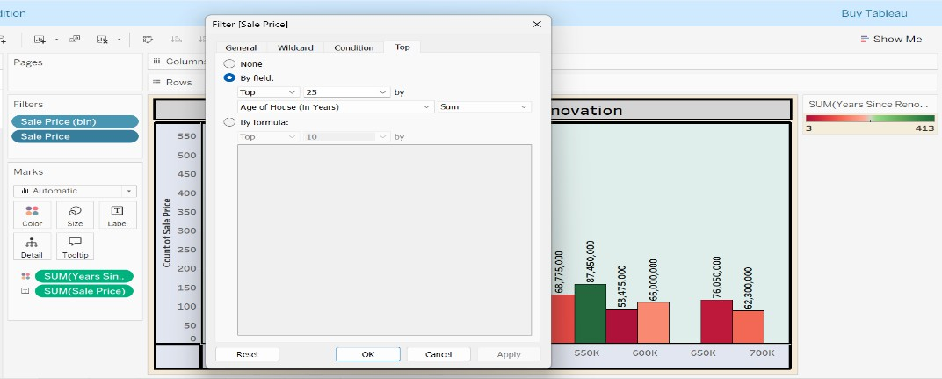

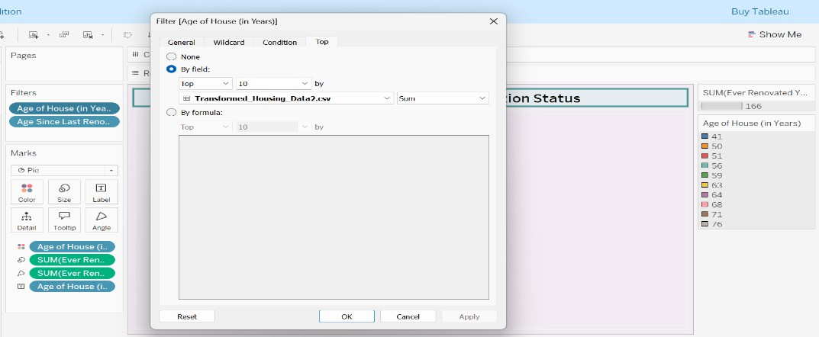

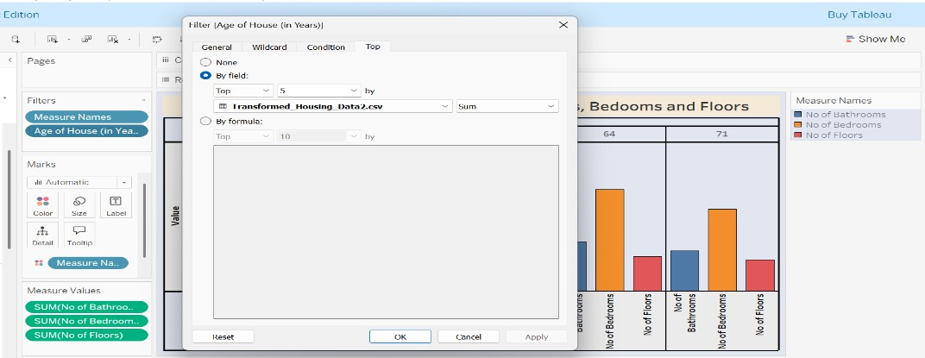
4. | Calculation fields Used | Age Since Last Renovation = IF [Ever Renovated Yes] > 0 THEN ‘YES’ ELSE ‘NO’  END  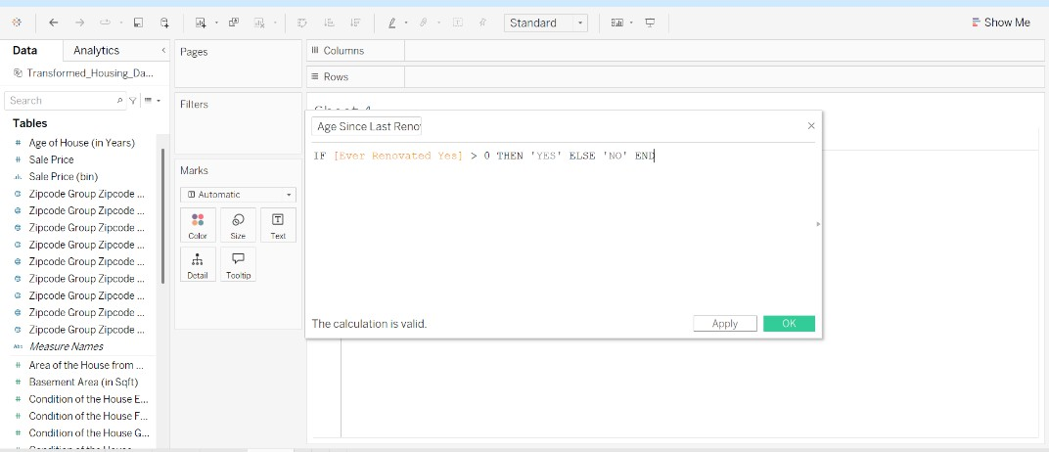

5. | Dashboard design | No of Visualizations / Graphs –  Total Sales By Year Since Renovation Distribution of House Age by Renovation Status  House Age Distribution by Number of Bathrooms, Bedrooms and Floors  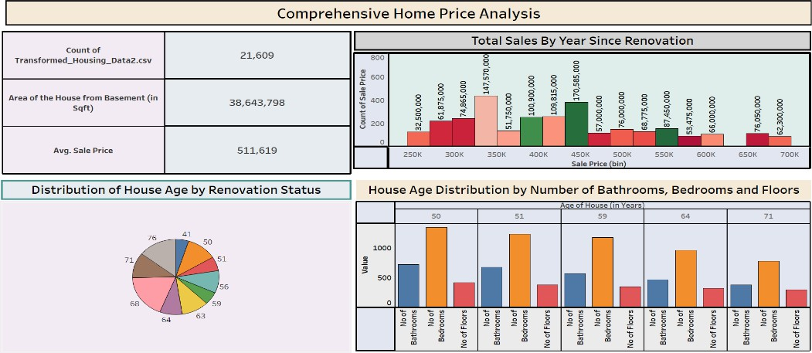
6 | Story Design | No of Visualizations / Graphs –  Stort include 4 Sheets.  